770 litre  - Code: MP8409  - Material: HDPE  - Ext. Top: 772 x 1260 x 1295mm (H)  - Int. Base: N/A  - Wheel size: 200mm  - Max Load: 310kg  - Stack Height: N/A  - Nest Height: N/A  - Colour: Grey, Green | 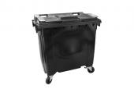  click image for larger view

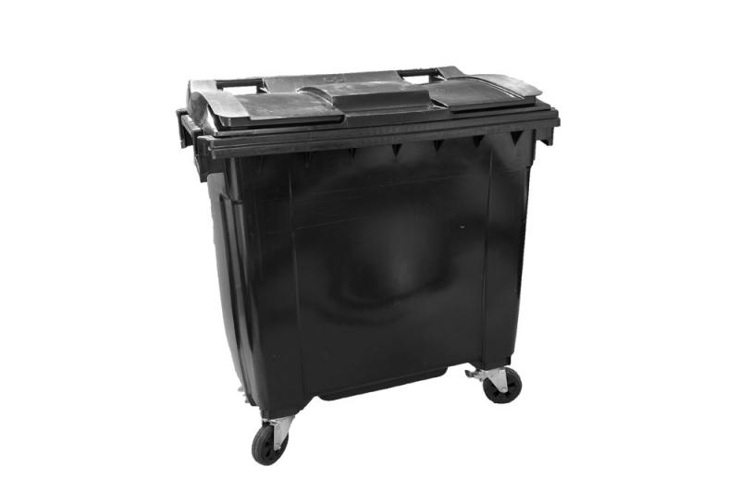
140-litre two-wheeled bin  - Code: CT8108  - Material: HDPE  - Ext Top: 482 x 587 x 1060mm (H)  - Int. Base: N/A  - Wheel size: 200mm  - Max Load: 60kg  - Nest Height: 130mm  - Colour: Red, Blue, Green, Yellow, Light Blue, Black, Grey | 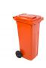  click image for larger view  View 360° (left to right)

